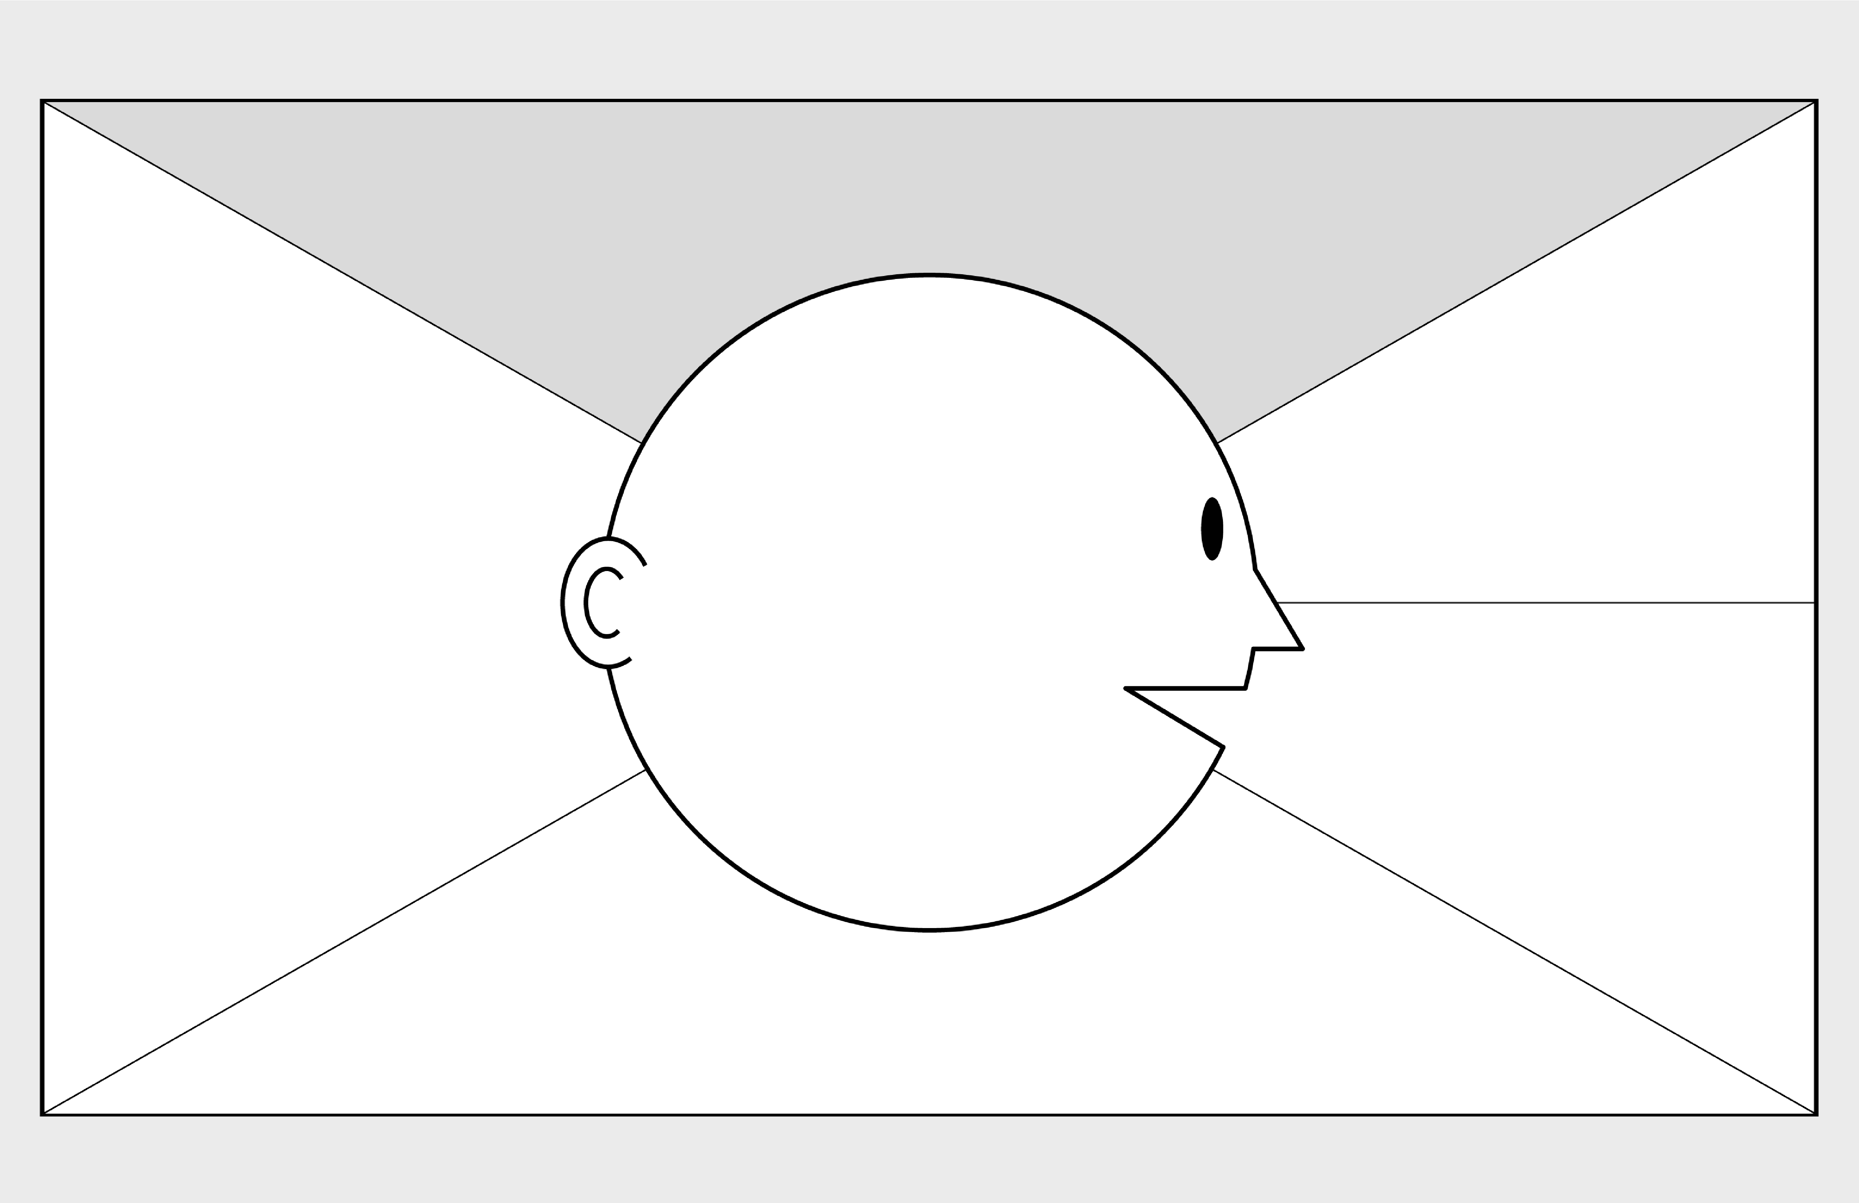

**Empathy Map Canvas**

*Designed for: Customer*

*Designed by: Yan*

*Date:*

*Version:*

**WHO**

**are we empathizing with?**

**What do they need to DO**

**?**

What do they need to do differently?

Create a customer profile

What job(s) do they want or need to get done?

Travel

What decision(s) do they need to make?

Where to travel, the costs and worthiness

How will we know they were successful?

Satisfaction is fulfilled

Who is the person we want to understand? Customer

What is the situation they are in? The customer could not find their best RM or waited too long for the RM to pick up their calls.

What is their role in the situation? Trying to purchase a travel packages or receive information about the services.

**GOAL**

**What do they**

**SEE**

**?**

**What do they**

**SAY**

**?**

**What do they**

**DO**

**?**

**What do they**

**HEAR**

**?**

**What do they**

**THINK**

**and**

**FEEL**

**?**

What do they see in the marketplace?

Different travel packages

What do they see in their immediate environment?

the most popular place to visit

What do they see others saying and doing?

Reputation and reviews of the vendor websites

What are they watching and reading?

The available options

What have we heard them say?

I want to travel

I want my trips planned and organized

I want to make some friends

What can we imagine them saying?

Where should I visit? Maybe I could make a call to check if any plan suit best for me.

What do they do today?

Call the travel company agent

What behaviour have we observed?

The customer wants the most value and best travel plan

What can we imagine them doing?

Check reviews of the travel sites

Research where they want to visit

What are they hearing others say?

Compliment and complaints

What are they hearing from friends?

Advise and opinions

What are they hearing from colleagues?

Recommendations

What are they hearing second hand? XXX is very reliable

-

© 2017 Dave Gray, xplane.com

Last updated on 16 July 2017. Download a copy of this canvas at http://gamestorming.com/empathy

-

map/

**1**

**2**

**3**

**4**

**5**

**6**

**7**

**PAINS**

**GAINS**

What are their fears,

frustrations, and anxieties?

What are their wants,

needs, hopes and dreams?

What other thoughts and feelings might motivate their behavior?

* Can meet new people
* New experience and memory
* Is it safe?
* Flexibility?
* Do I receive sufficient information about the trip?
* Will I like the place that will be visited?
* Is it worth?